INFR3120 – Assignment 3 Project Plan
Project Title: Workout Tracker
Student Name: Mario Solundu Onyido
Course: INFR3120 - Web and Script Programming
Date: 2025-11-19

1. Overview of the Application
The Workout Tracker is a simple web app that lets users log their gym sessions and keep everything in one place. For each workout, you can record the exercise, which muscle group it hits, sets, reps, weight, intensity, and the date. The idea is to make it easy to see your progress over time, no more scattered notes or forgotten PRs.

Everything gets saved in a MongoDB database, so you can go back to old workouts, edit them if your program changes, or delete sessions you don’t need anymore. I built it with Node.js + Express on the backend, Mongoose for the database, EJS for templating, and Bootstrap so it actually looks clean and professional, like a real fitness log you’d want to use every day.

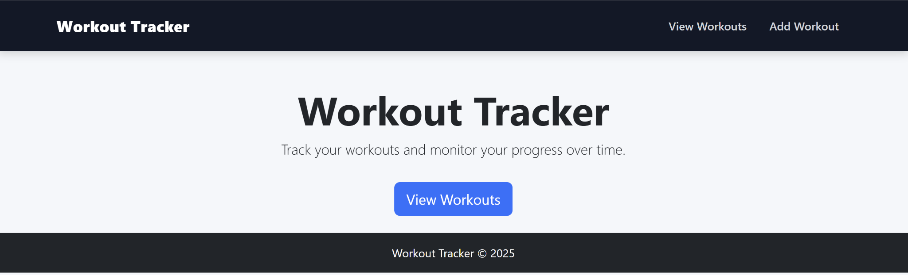

2. Problem Statement
A lot of people at the gym have the same problem: they can’t remember what they lifted last week, how many reps they did, or even which exercises they hit. That makes it tough to know if they’re actually getting stronger or just spinning their wheels. Most just scribble stuff in a notebook or type random notes on their phone, and before long everything’s a mess and half the info is lost.

The Workout Tracker fixes that. It gives you a clean, dedicated place to log every session, exercise, muscle group, sets, reps, weight, intensity, date, without the clutter. You can pull up your history in seconds, edit old workouts when your program changes, or delete sessions you don’t need anymore. Basically, it’s a simple, organized log that actually stays organized and helps you see real progress.

3. Target Users
The Workout Tracker is built for:

- Beginners and intermediate lifters who just want a straightforward way to log workouts without all the extra features of big fitness apps.
- Students (or anyone learning fitness) who need to keep a clean record of their routines.
- People who like tracking progress but don’t want the bloat and subscriptions that come with commercial platforms.

4. Core Features (CRUD Functionality)
The Workout Tracker will implement full Create, Read, Update, and Delete (CRUD) functionality on a single Workout collection.

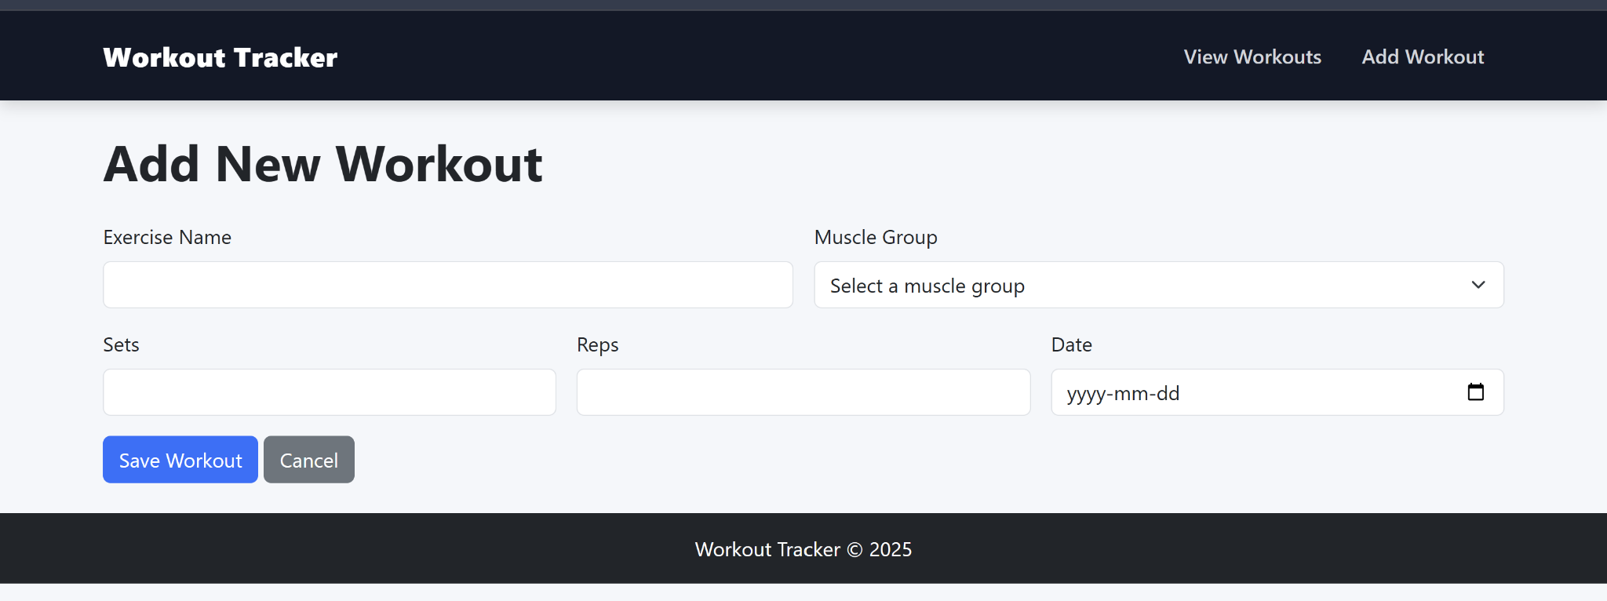

Create (C)
A “New Workout” form will allow the user to add a workout with the following fields:
- Exercise Name
- Muscle Group (e.g., Chest, Back, Legs, Arms, Shoulders, Core)
- Sets
- Reps
- Date of Workout
When submitted, the workout will be saved in the MongoDB database using Mongoose.

Read (R)
A main “Workouts” page will display all workout records in a directory-style listing.
The list will use a Bootstrap-styled table or card layout and will display key information such as:
- Exercise Name
- Muscle Group
- Sets
- Reps
- Date

Update (U)
Each workout entry will include an “Edit” option.
The Edit Workout page will:
- Display a pre-filled form containing the existing record
- Allow users to update all five fields (Exercise Name, Muscle Group, Sets, Reps, Date)
Once saved, the updated workout will be written back to the database.

Delete (D)
Each workout entry will include a “Delete” option.
When clicked, the user will be taken to a Delete Confirmation Page that:
- Displays the workout’s details
- Asks, “Are you sure you want to delete this workout?”
- Provides Confirm Delete and Cancel options
Only after confirming will the workout be permanently removed from the database.

